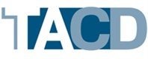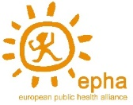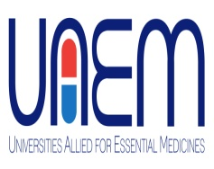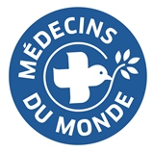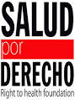

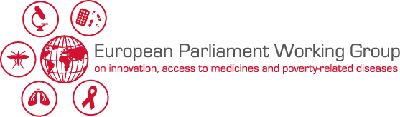

***“It is not healthy: Mending the broken medicines innovation model”***

***European Parliament (room JAN 6Q2), 2 December 2015, 13:00-15:00***

Dear friends,

We would like to invite you to the conference **“It is not healthy: Mending the broken medicines innovation model”** under the auspices of MEPs **Marian-Jean MARINESCU (EPP, RO), Nessa CHILDERS (S&D, IE), Fredrick FEDERLEY (ALDE, SE – to be confirmed), Lola Sanchez CALDENTEY (GUE/NGL, ES), SKA KELLER (Greens/EFA, DE-to be confirmed)** with the support of the TransAtlantic Consumer Dialogue (TACD), the European Public Health Alliance (EPHA), Médecins du Monde (MdM) International network, Universities Allied for Essential Medicines (UAEM Europe), Salud Por Derecho in collaboration with the European Parliament Working Group on innovation, access to medicines & poverty-related diseases.

Health is a fundamental universal right and access to medicines is part of it. The EU and its Member states are committed to universal and equitable access to healthcare. Nevertheless, millions of European patients suffer from the lack of affordability of many life-saving medicines across Europe. The debate will examine the status quo regarding access to medicines in Europe and explore policy recommendations for more affordable medicines. Possible solutions to be considered will be: price and data transparency, cost-therapeutic benefit assessment of medical products and greater generic competition. We shall also debate new biomedical R&D strategies that increase the social return of public investments and promote affordable health-driven innovation which “de-links” research costs from final medicine prices.

**Programme (13:00-15:00, room JAN 6Q2)**

Welcoming remarks by sponsoring MEP

**What is the diagnosis for our medical innovation and medicines pricing ills?**

Introduction by sponsoring MEP

*Moderated by Yannis Natsis @ynatsis, advocacy advisor on access to medicines, TACD*

* **Xavier Prats Monné**, Director-General, DG SANTE, European Commission (to be confirmed)
* **Teresa Alves**, International Policy Adviser, La Revue Prescrire
* **Dr. Fernando Lamata,** *@LamataF,* Consejería de Sanidad de la Comunidad de Madrid, Madrid, Spain – member of the EC’s Expert Panel Working Group on access to health care
* **Dr. Antje Haas**, Head of our pharmaceuticals department, GKV-Spitzenverband

Q&A session

**What are some of the possible cures for our ailing and expensive pharmaceutical model?**

Introduction by sponsoring MEP

*Moderated by David Hammerstein @DaHammerstein, senior policy advocate, TACD*

* **Rachel Kiddell-Monroe,** *@Access2Rachel* Special Advisor to Universities Allied for Essential Medicines (UAEM) *@UAEM*
* **Dr. Bernard Pécoul,** Executive Director, Drugs for Neglected Diseases Initiative (DNDi) *@DNDi*
* **Els Toreele,** *@ElsTorreele* Director of the Open Society Public Health Program’s Access to Essential Medicines Initiative @osfHealth

Q&A session

Concluding remarks by sponsoring MEP

Please join the discussion on twitter using **#unHealthy.**

We would kindly ask you to register your attendance (please mention title & organisation represented) by sending an email to [a2m.europe@gmail.com](mailto:a2m.europe@gmail.com) **by Wednesday 25 November 2015.**

Should you require a badge to access the European Parliament, please do not forget to provide us with your full name, nationality, passport/ID number and date of birth. Badges will be handed out at the “Altiero Spinelli” entrance of the European Parliament on Rue Wiertz 60 as of noon on the day of the event (please look for respective desk/poster).

A light lunch will be served at the start of the hearing.