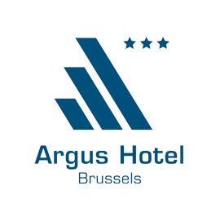

**\*\*\* This form confirms your reservation with "TACD - BEUC"in Argus Hotel\*\*\***

**To be returned by the 15/12/2015 maximum**

**By email:** [**info@argus-hotel.be**](mailto:info@argus-hotel.be) **or by fax: +32 2 514 12 22**

Arrival date:

Departure date:

Client name:

Contact email:

Phone number:

Remarks:

**The following credit card can be used as guarantee for my reservation:**

Card: VISA – MASTERCARD – AMEX – DINNERS

Nr: exp…………..

Credit card owner name:

Credit card owner’s signature:

Choose your room type:

* **Single room:** **99,00 €** /night during the week // **69,00 €**/ night during the week-end,
* **Double room: 109,00€** / night during the week,

**79,00 €**/night during the weekend.

***Wi-Fi, continental breakfast, taxes & service included.***

Should you need any further information, please feel free to contact us.   
Looking forward to welcoming you in our hotel,

Bien à vous / Met vriendelijke groeten / Best regards,

**Argus Hotel Brussels**

6 Rue Capitaine Crespel  - 1050 – Brussels – Belgium

**T** +32 (0)2 514 07 70 — **F** +32 (0)2 514 12 22 —[info@argus-hotel.be](mailto:info@aqua-hotel.be)

cid:image002.png@01CF6836.CADABFD0

[Official Website](http://www.a-hotels-brussels.com/) — [Facebook](https://www.facebook.com/pages/Argus-Hotel-Brussels/129233803813053)  — [Eco Partner](http://www.grainedevie.org/)

cid:image002.png@01CF6836.CADABFD0

Please consider the environment before printing this email.

[](http://www.a-hotels-brussels.com/)