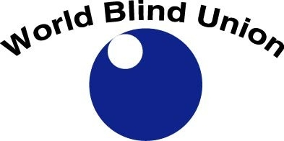
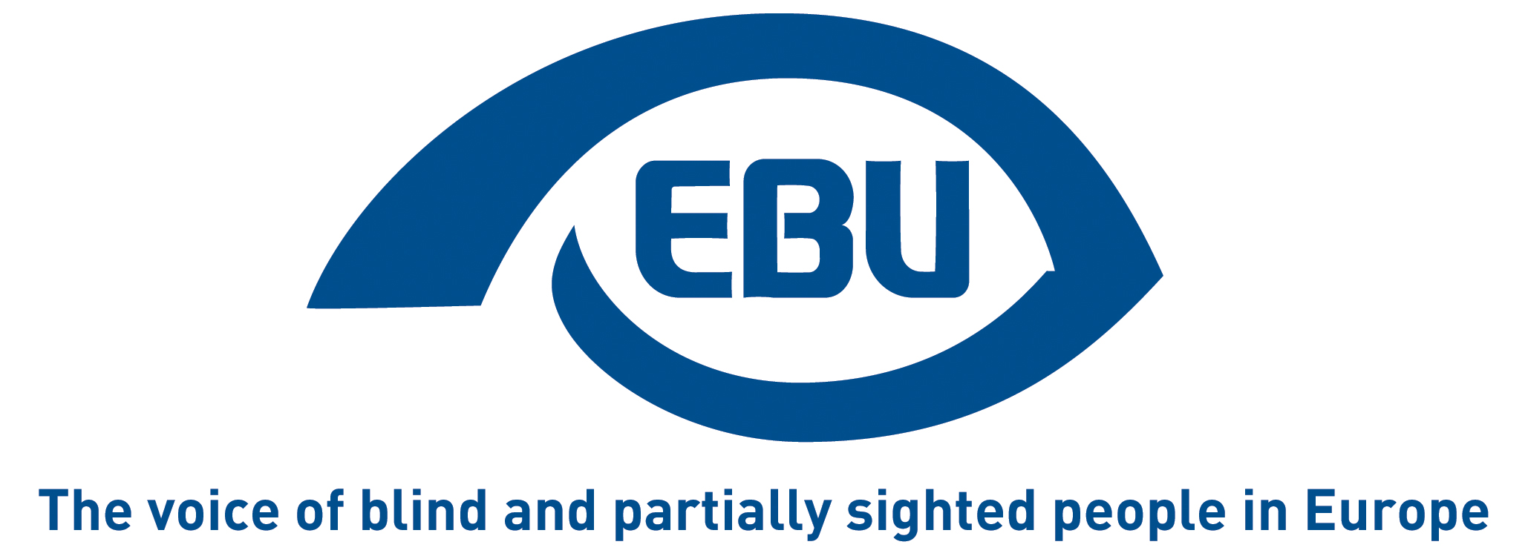

EU: End the book famine!
Ratify the Marrakesh Treaty
for the right to read of blind and other visually impaired persons

Sponsoring MEPs: Enrique CALVET (ALDE, ES), Max ANDERSON (Greens/EFA, SE) – more MEPs to be confirmed
Co-organisers:
- Trans-Atlantic Consumer Dialogue (TACD)
- European Blind Union (EBU)
- World Blind Union (WBU)
- Knowledge Ecology International (KEI) Europe
Date of event: 2 December 2014, 10:00-12:00
Location: European Parliament, room ASP A5G-1, Brussels

On June 28th, 2013 the Marrakesh Treaty to Facilitate Access to Published Works by Visually Impaired Persons and Persons with Print Disabilities was concluded in Morocco.

This international binding UN/WIPO treaty aims at ending the “book famine” that deprives 250 million people of access to culture and education. Visually impaired persons only have access to between 1 and 5% of the books published. The agreement focuses on copyright exceptions to facilitate the creation of accessible and affordable versions of books and other copyrighted works. It sets a norm for countries ratifying the Treaty to have a domestic copyright exception covering these activities, and allowing for the import and export of such material.

Objectives
The EU finally signed the Treaty in April 2014 and in October, 2014 the European Commission formally asked for authorization from the Council and the European Parliament to ratify the Treaty. Nevertheless, among a number of EU member states there is resistance against accepting EU competence over the ratification of the treaty despite the fact that both Commission and Council legal service opinions assert exclusive EU competence over this issue. If authorization of EU ratification is not accepted by EU member states, it will take many years before the Treaty is ratified and implemented.

Blind people, MEPs, the European Commission and other stakeholders will discuss the meaning of this landmark treaty for human rights and will urge swift ratification and implementation by the EU and its member states.

Programme
Welcoming remarks by Max ANDERSON (Greens/EFA, SE), JURI rapporteur on Marrakesh Treaty
Why the EU should ratify the Marrakesh Treaty now and how to make it happen

- Paco Martínez, Organización Nacional de Ciegos de España (ONCE)
- Wolfgang Angermann, President, European Blind Union
- Dan Pescod, International Campaigns Manager, Royal National Institute of the Blind, UK
- Representative of the European Commission, Digital Single Market

Closing remarks by Enrique CALVET (ALDE, ES)

Should you require a badge for the EP, please RSVP to ratify.tvinow@gmail.com
stating your full name, identity card/passport number, date of birth and nationality.

