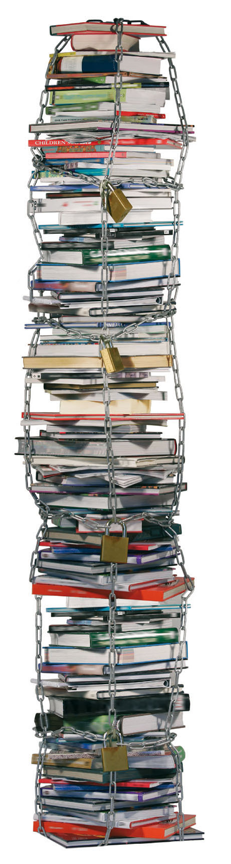
Help us
cut the
chains! 

EU: End the book famine!
Ratify the Marrakesh Treaty for the right to read of blind and other visually impaired persons!

Tuesday, 2 December 2014
10:00-12:00
Room: ASP A5G-1, European Parliament

Hosted by:
Enrique CALVET (ALDE, ES)
Max ANDERSSON (Greens/EFA, SE)

European Blind Union (EBU), World Blind Union (WBU), TACD, KEI Europe


Should you require a badge for the EP, please RSVP to ratify.tvinow@gmail.com stating your full name, identity card/passport number, date of birth and nationality.

