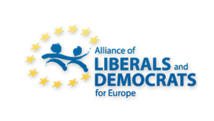

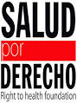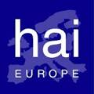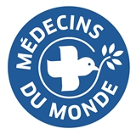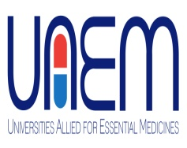

‘’Can we afford our medicines?
The access to medicines crunch in Europe”
European Parliament (room A3G-3), 12 November 2014, 12:30-15:00
Dear friends,

We would like to invite you to the conference “Can we afford our medicines? The access to medicines crunch in Europe” under the auspices of MEPs Nessa CHILDERS (S&D, IE), Beatriz BECERRA BASTERRECHEA (ALDE, ES), Kostas CHRYSOGONOS (GUE/NGL, EL), Michèle RIVASI (Greens/EFA, FR) with the support of the TransAtlantic Consumer Dialogue (TACD), Salud por Derecho, Health Action International (HAI) Europe, Doctors of the World – Médecins du monde International Network, Universities Allied for Essential Medicines (UAEM).

Health is a fundamental universal right and access to medicines is part of it. The EU and its Member states are committed to universal and equitable access to healthcare. Nevertheless, millions of European patients suffer from the lack of affordability of many life-saving medicines across Europe. The debate will examine the status quo regarding access to medicines in Europe and explore policy recommendations for more affordable medicines. Possible solutions to be considered will be: new forms of pooled procurement, price and data transparency, cost-therapeutic benefit assessment of medical products and greater generic competition. We shall also debate new biomedical R&D strategies that increase the social return of public investments and promote affordable health-driven innovation which “de-links” research costs from final medicine prices.

Programme (12:30-15:00, room A3G-3)

Welcoming remarks by Kostas CHRYSOGONOS (GUE/NGL, EL)

Affordable access to medicines: the situation on the ground
Introduction by Beatriz BECERRA BASTERRECHEA (ALDE, ES) @beatrizbecerrab
Moderated by David Hammerstein @DaHammerstein, Senior policy advocate, TACD

- François Berdougo @FBerdougo, Secretary General of the Harm Reduction Working Group of Médecins du Monde @MdM_France
- Gonzalo Fanjul @GonzaloFanjul, Policy Director, IS Global Barcelona Institute for Global Health @ISGlobalorg
- Rohit Malpani @MSF_access, Director, Access Campaign, Médecins Sans Frontières (MSF)

Q&A session

What can we do about the high cost of medicines?
Introduction by Michèle RIVASI (Greens/EFA, FR) @MicheleRivasi
Moderated by Ellen ‘t Hoen @ellenthoen, Medicines Law & Policy.

- Jamie Love @jamie_love, Director, Knowledge Ecology International (KEI) & U.S. Chair of the Intellectual Property Committee, TACD
- Teresa Alves, International Policy Adviser, La Revue Prescrire,
- Prof. dr. Graham Dukes, University of Oslo

Q&A session

The European Commission will be represented by DG SANCO & DG Enterprise

Concluding remarks by Nessa CHILDERS (S&D, IE) @nchildersMEP

Please join the discussion on twitter using #a2mEurope. Also note that the event will be webstreamed live at http://greenmediabox.eu/en/live/can-we-afford-our-medicines

We would kindly ask you to register your attendance (please mention title & organisation represented) by sending an email to a2m.europe@gmail.com by Thursday 6 November 2014. Should you require a badge to access the European Parliament, please do not forget to provide us with your full name, nationality, passport/ID number and date of birth.

A light lunch will be served at the start of the event.

